**# Travel and Tourism Management System**

## Overview

The **Travel and Tourism Management System** is a Java Swing-based desktop application designed to streamline travel planning and management. This system provides a centralized platform for users to explore travel packages, book hotels, manage personal details, and make payments efficiently.

The project aims to reduce manual work for travel agencies and improve the user experience for travelers.

---

## Features

### User Features

- Add, view, update, and delete personal details.

- Explore and check different travel packages.

- Book travel packages and hotels.

- View booked packages and hotels.

- Check hotel details with image slideshow.

- Access destinations and tour details.

- Calculate total prices for bookings.

- Integrated calculator and notepad for convenience.

### Admin Features

- Manage travel packages (add, update, remove).

- Monitor customer bookings and payments.

### Other Features

- Real-time price calculation based on number of persons, days, AC/Non-AC room, and food inclusion.

- Payment management for booked packages and hotels.

- User-friendly interface with a visually appealing GUI using Java Swing.

---

## Technologies Used

- **Java SE** (Swing, AWT)

- **MySQL** (Database)

- **JDBC** (Database connectivity)

- **Threading** (for hotel image slideshow)

- **Image Handling** (ImageIcon, JLabel)

---

## Database Tables

The application uses the following tables in the `travelmanagementsystem` database:

| Table Name | Description |

|-----------------|--------------------------------------------------|

| `account` | Stores user account information |

| `customer` | Stores personal details of customers |

| `hotel` | Stores hotel details |

| `bookhotel` | Stores hotel bookings |

| `bookpackage` | Stores travel package bookings |

---

## Installation and Setup

1. **Clone the repository:**

```bash

git clone <repository-url>

2.Set up the MySQL database:

3.Create a database named travelmanagementsystem.

4.Create the required tables (account, customer, hotel, bookhotel, bookpackage).

5.Update the database credentials in Conn.java if needed.

6.Compile and run the application:

7.Launch the Dashboard and start managing bookings.

8.Screenshots

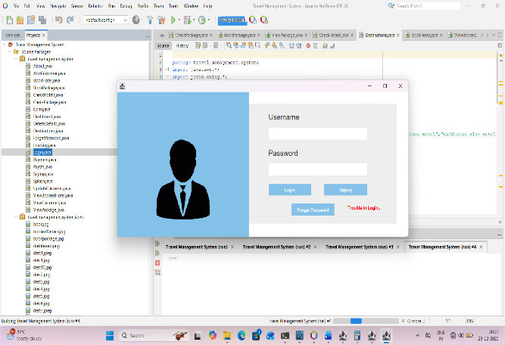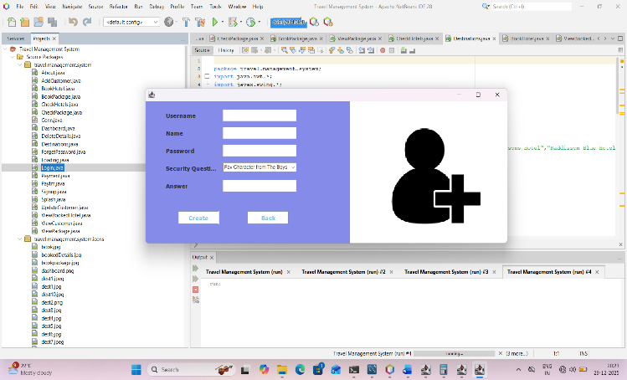

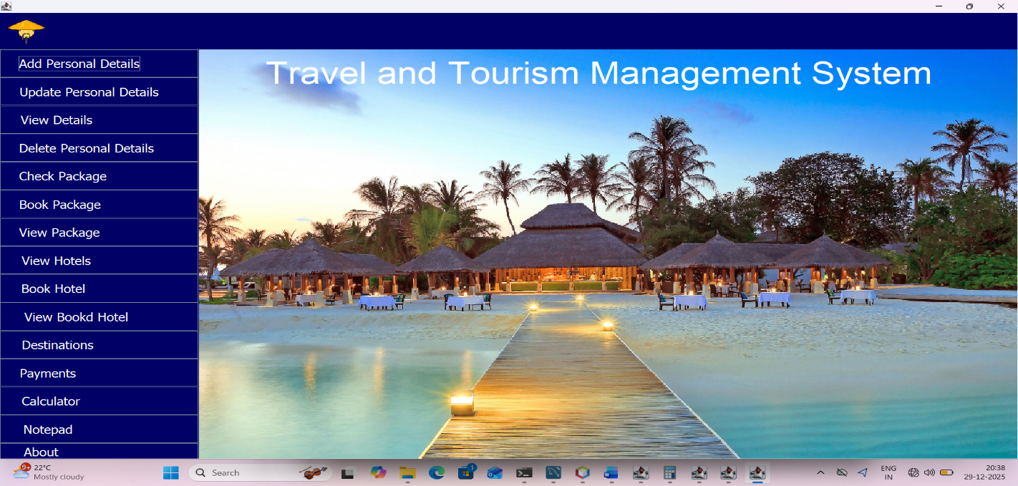

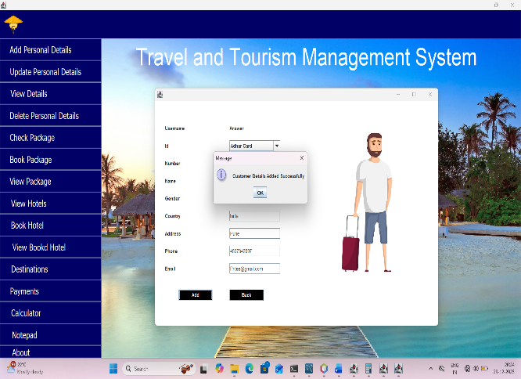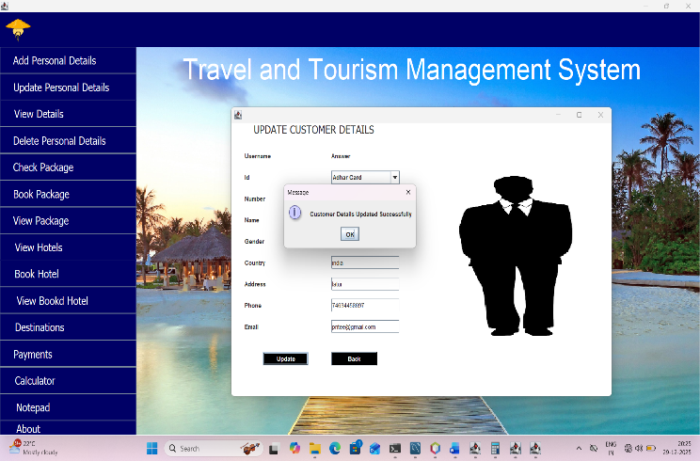

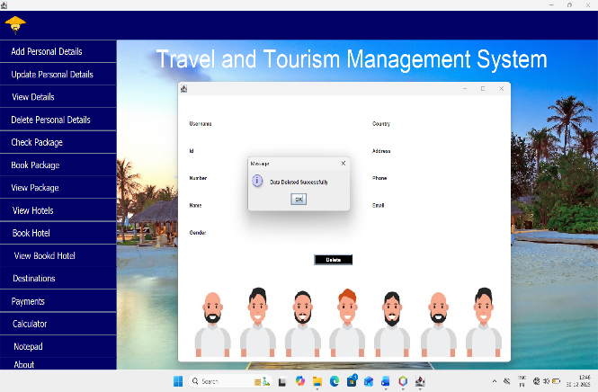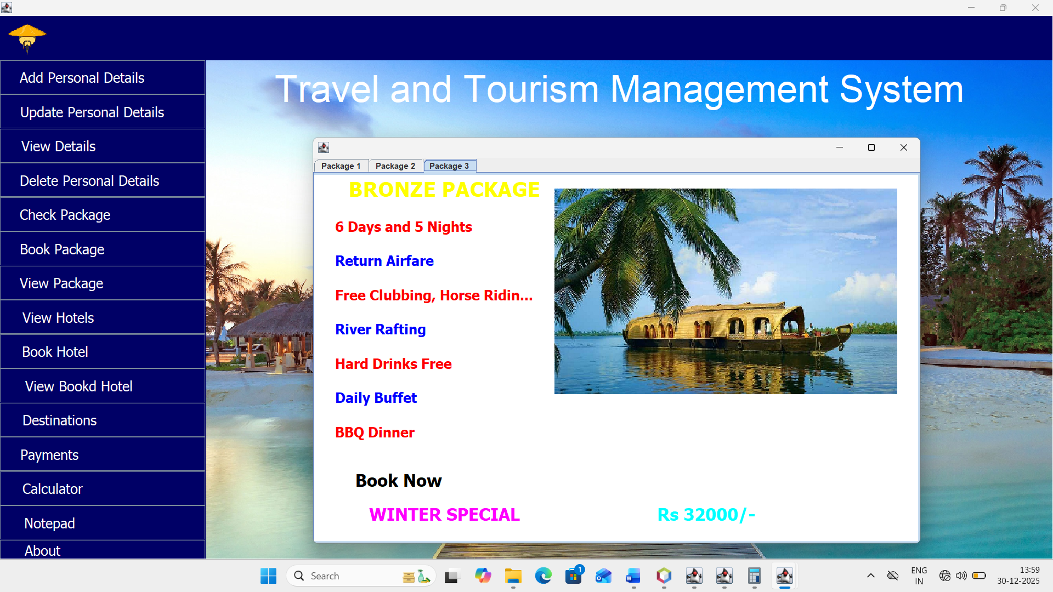

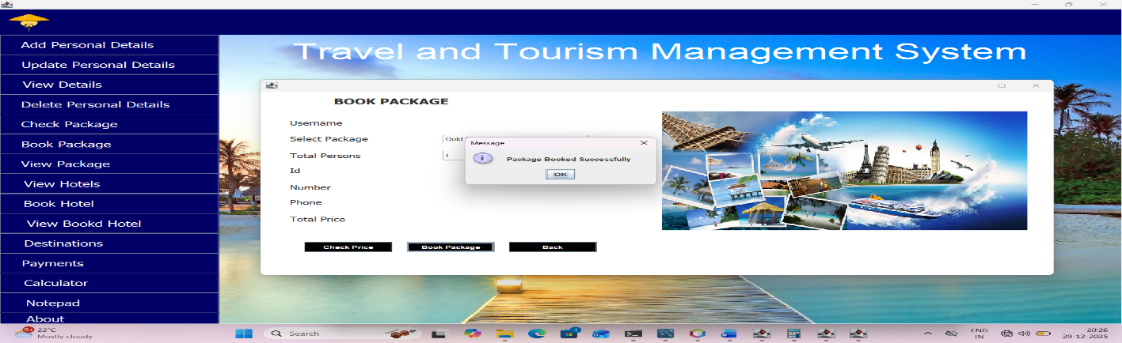

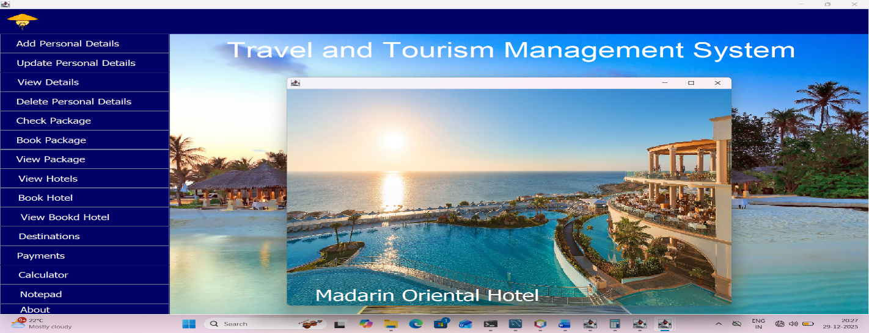

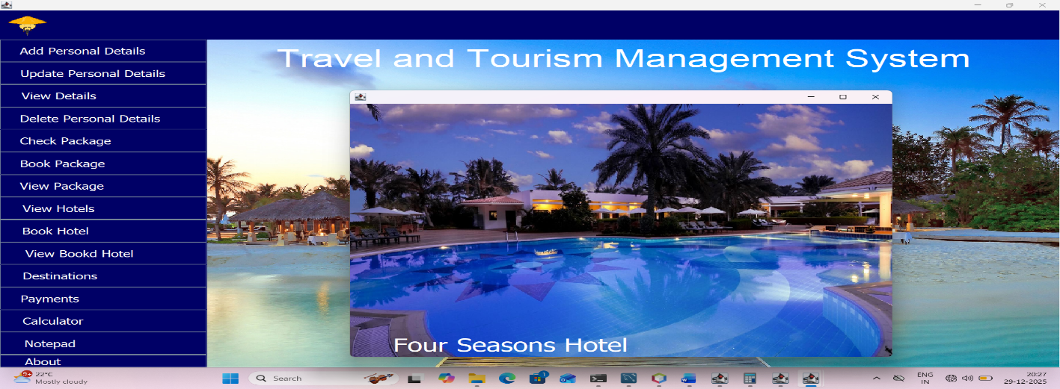

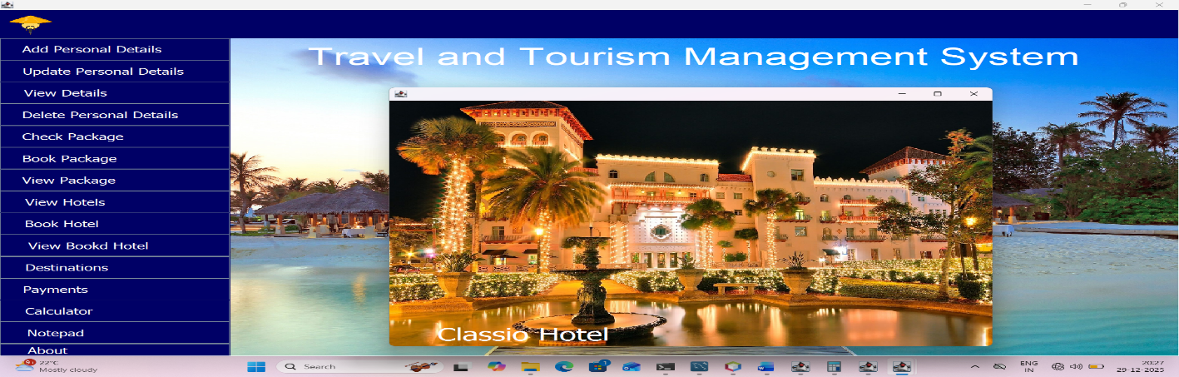

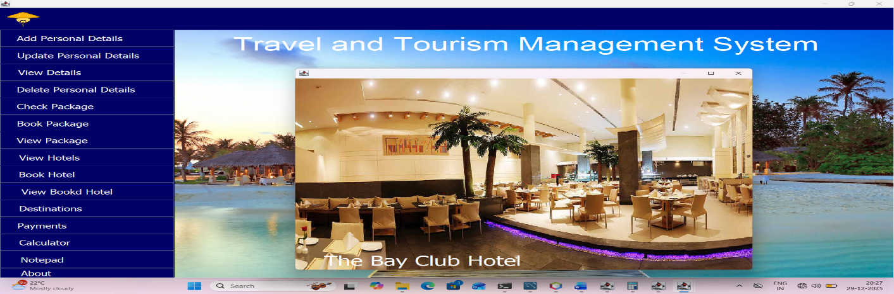

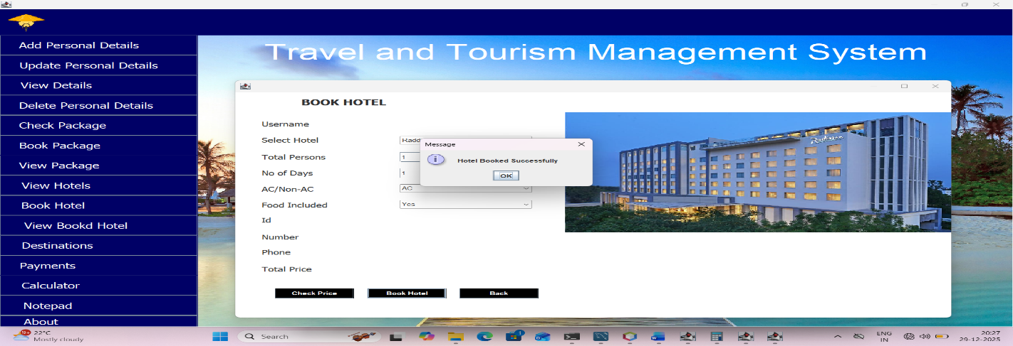

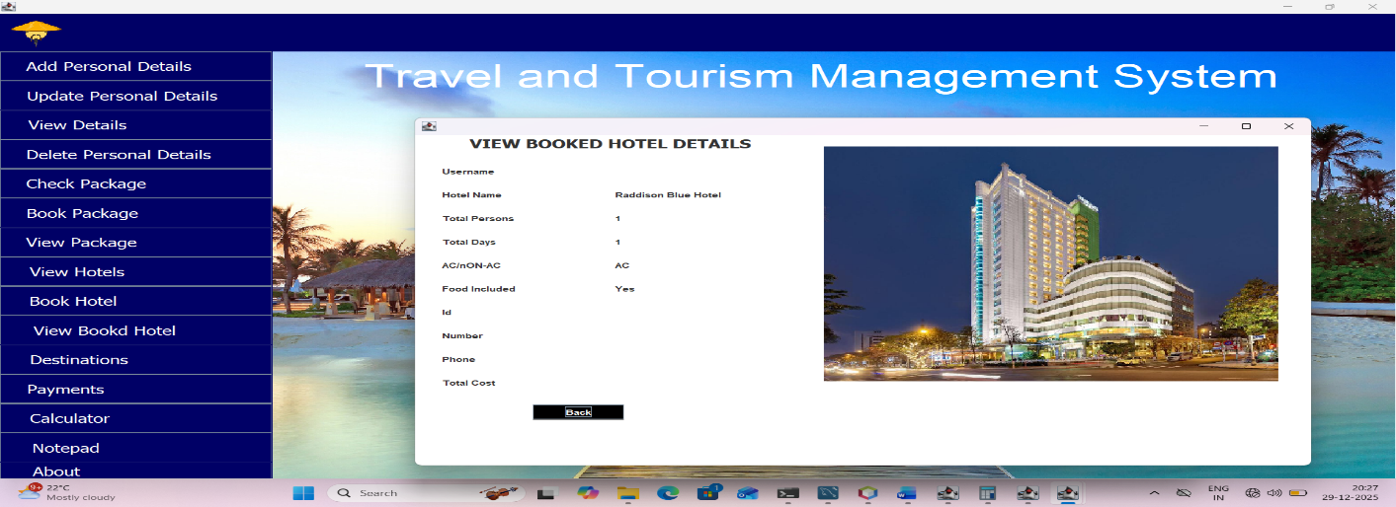

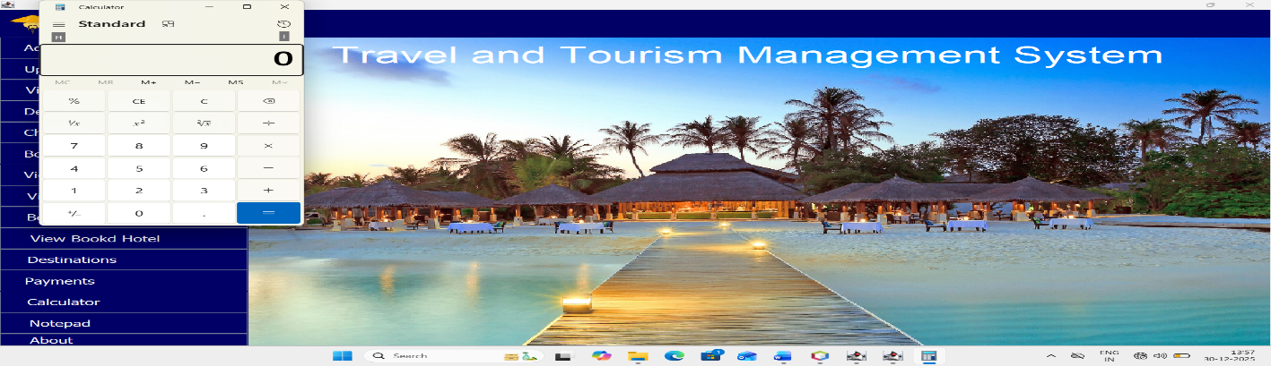

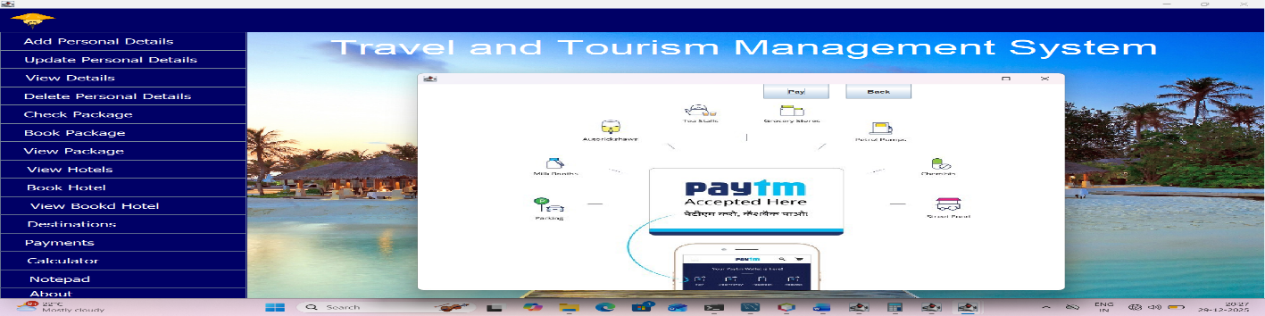

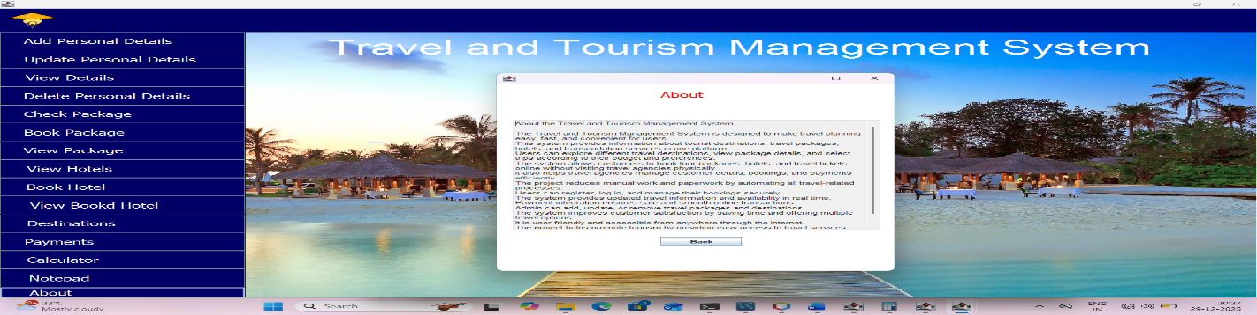

Author

Pritee Kolsure